Healthy Living: A Colorful Diet for Health and Happiness

The recommended dietary guidelines for Americans have long emphasized the need for a variety of nutrient dense choices in our diet. The guidelines also suggest eating different color foods to get the maximum benefit from your daily servings of fruits and vegetables. Specifically, [dietary guideline number two](https://health.gov/sites/default/files/2019-09/2015-2020_Dietary_Guidelines.pdf) encourages a healthy eating pattern that prioritizes variety and nutrient density in addition to meeting your daily servings.

Why focus on colors?

Most Americans know they’re supposed to eat five servings a day, but according to the [Annual Phytonutrient Report](https://www.amwayglobal.com/wp-content/uploads/2017/09/global_phytonutrient_report_commissioned_by_the_nutrilite_health_institute.pdf), a mere 5% of men and 7% of women in America were consuming their daily recommended fruit and vegetables—much less eating from each color variety. And it’s not just Americans that are having trouble meeting these guidelines; worldwide, 60–87% of us eat fewer fruits and vegetables than we should.

Obviously, getting those five servings can be challenging. There is [evidence](https://www.hindawi.com/journals/jnme/2019/2125070/) that suggests focusing on eating from the food color spectrum each day is a practical and effective strategy for meeting your serving guidelines.

If you focus on colors instead of servings, you may think of your fruits and vegetables differently. Instead of thinking, “Ugh, I guess I should have an apple—again.” Try focusing on variety in your fruit and vegetable choices. Think, “I haven’t had anything purple today; maybe I’ll add some berries to my afternoon snack.”

Falling into a rut, eating the same kinds of fruits and vegetables each week, can lead to boredom and ultimately disinterest. Variety is key, not only for getting diverse benefits, but also staying interested in these natural superfoods.

Why are fruit and vegetable colors important?

In a nutshell, the color of a plant usually signals the kind of nutrients it contains. For example, yellow and orange foods get their color from carotenoids and purple and blue foods get their color from anthocyanins. Both carotenoids and anthocyanins have antioxidant effects when we consume them.

Bioflavonoids, like anthocyanins, can also help give plants their colors and have numerous health benefits for us. For example, foods rich in bioflavonoids may [fight premature aging and improve brain function](https://www.ncbi.nlm.nih.gov/pmc/articles/PMC7211351/).

Basically, pigments in plants signal antioxidants and other nutrients. These pigments provide anti-inflammatory and immune benefits when we humans consume them. Let’s break down some of the benefits of the different color groups and look at ways we can make different colors part of our routine diet.

Red

The red color group is pretty popular, so you may already know a bit about these foods. For example, some red foods contain lycopene which is helpful in promoting, [prostate, heart, and lung health](https://www.amwayglobal.com/wp-content/uploads/2017/09/global_phytonutrient_report_commissioned_by_the_nutrilite_health_institute.pdf). What you might not know is that red foods are among the highest in vitamin C content. Surprised?

We often think vitamin C in connection with citrus fruits, but most red foods contain very high concentrations of vitamin C. Because of this, red foods can seriously help reduce inflammation—the ultimate enemy of immune function and cardiovascular health. So, eating red foods can help you fight or prevent health issues like hypertension and high cholesterol.

* Tomatoes
* Pomegranate
* Watermelon
* Red bell pepper
* Strawberries
* Red onion
* Red beets

You do not just have to eat these foods raw to get the health benefits. A [2015 study](https://www.mdpi.com/2072-6643/8/3/170) on the health benefits of tomato sauce with olive oil showed that consuming this type of tomato substance helped decrease body inflammation and total cholesterol. So, get creative with your veggies. Consuming them in different forms can sometimes increase the nutritional benefits while keeping you interested in eating them.

Orange

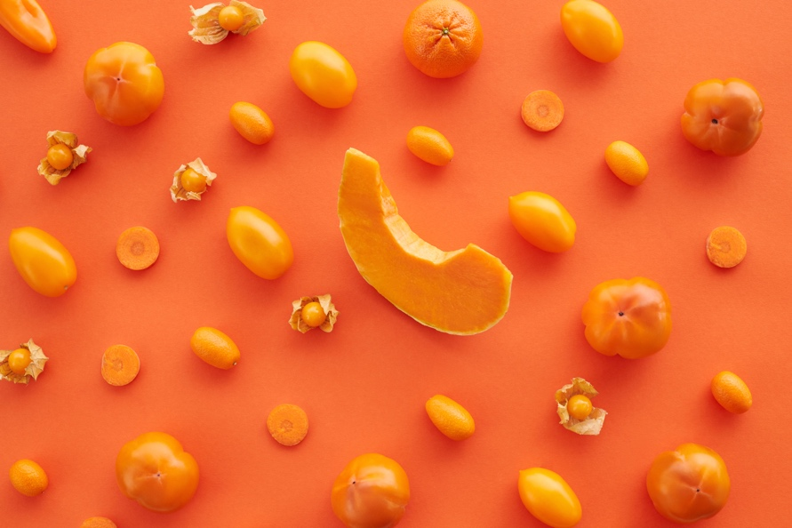

This color category might immediately make you think of carrots, and the adage that eating carrots will make your eyes shine. It’s true that orange foods contain the carotenoids alpha and beta carotene, which are important for your eye health (and, incidentally, your heart health). But did you know that orange fruits and vegetables have also been linked to endocrine and reproductive health?

[A detailed review of the research involving food color](https://www.hindawi.com/journals/jnme/2019/2125070/) varieties revealed that orange foods are tied to the health of both male and female reproductive systems. The collected research indicated that a lack of beta-carotene may even be linked to infertility. Much of the data tying orange-colored foods to reproductive health is relatively new, but it is notably consistent and promising.

* Carrots
* Peaches
* Oranges
* Orange bell pepper
* Mango
* Pumpkin
* Yams
* Cantaloupe

Orange foods are particularly rich in carotenoids. A study on the connection between carotenoids and endocrine health found that eating food rich in carotenoids may [reduce your risk of insulin resistance](https://www.researchgate.net/profile/Sajad-Khalili-Moghadam/publication/289501342_Association_of_dietary_carotenoids_and_the_incidence_of_insulin_resistance_in_adults_Tehran_lipid_and_glucose_study/links/5ae03a30aca272fdaf8bd83f/Association-of-dietary-carotenoids-and-the-incidence-of-insulin-resistance-in-adults-Tehran-lipid-and-glucose-study.pdf) (a big risk factor for multiple diseases including type 2 diabetes and Alzheimer’s). Carotenoids are a powerful health ally that can also be found in vegetables and fruits of other colors, like watermelon and kale.

Yellow

Ever had a glass of lemon water with your dinner? Or drank some ginger tea when you had an upset stomach? These are examples of how yellow foods can have a very quick and obvious effect on your digestive health. Yellow foods contain a variety of nutrients that help your digestive health. For example, in addition to healthy amounts of dietary fiber, there are [bioflavonoids in yellow foods that support gut health](https://atlasbiomed.com/blog/eat-the-rainbow-guide-to-yellow-foods/).

* Lemons
* Ginger
* Pineapple
* Corn
* Banana
* Gold potatoes
* Acorn squash

In this color category there are some special foods. Lemons are acidic, and this low pH of lemons may help the stomach do its job. Since your stomach is busy breaking down the food you eat, it needs to be much more acidic than the rest of your body ([a pH between 1.35–3.5](https://www.ncbi.nlm.nih.gov/pmc/articles/PMC3195546/) versus 7.35).

Another fruit, pineapple, contains the enzyme bromelain. Bromelain is known to help break down and digest food—particularly any old remnants of undigested food.

Unsurprisingly, ginger contains gingerol, which is a super potent phytonutrient that has been studied for its [anti-inflammatory and antioxidant](https://www.ncbi.nlm.nih.gov/pmc/articles/PMC3665023/) properties as well as its [anti-cancer](https://europepmc.org/article/med/32951584) effects.

Green

When you are a kid, the last thing you want to eat are your green foods—even though your mom kept putting them on your plate. Broccoli, brussels sprouts, spinach: basically, a kid’s worst nightmare. So why did your mom keep trying to make you eat greens? Because green vegetables are essential for your health—particularly your cardiovascular health.

According to a [2016 study](https://www.ncbi.nlm.nih.gov/pmc/articles/PMC4973479/), regular consumption of green leafy vegetables reduced risk of cardiovascular disease by 15.8%. That’s right, just eating your greens everyday can give you a huge edge over one of the world’s most deadly diseases. Other studies have shown that cruciferous veggies, like broccoli and brussels’s sprouts, contain sulforaphane, which may help [prevent clot formation](https://pubmed.ncbi.nlm.nih.gov/23426129/).

* Spinach
* Chard
* Broccoli
* Limes
* Olives
* Bok choy
* Green cauliflower
* Celery
* Green beans
* Cucumbers

Basically, your mom knew best. Eat your greens.

Purple

Purple and blue foods are some of the most unique natural foods. The colors can be rich and deep and sometimes show up on foods that we expect to be white—like cauliflower and potatoes.

Purple fruits and vegetables have a fairly dense concentration of antioxidants which means that purple foods are loaded with health benefits. Purple and blue foods contain anthocyanins which can contribute to the health of your [heart, skin, brain, and your digestive system](https://www.amwayglobal.com/wp-content/uploads/2017/09/global_phytonutrient_report_commissioned_by_the_nutrilite_health_institute.pdf).

* Blueberries
* Purple grapes
* Eggplant
* Plums
* Figs
* Prunes
* Boysenberries
* Purple carrots
* Purple asparagus
* Purple cabbage

Purple and blue berries may even [prevent the effects of aging on your brain](https://pubmed.ncbi.nlm.nih.gov/22264107/). They help your overall brain function, including improving your memory and mood, and aid neuroplasticity, which is crucial for injury recovery and learning new things.

Try a variety of nutrient-rich choices

When you try eating each of the different colors, remember that a little color can go a long way. Foods like green tea, turmeric, and grape juice all count for their color categories.

Try different colors *and* different ways of preparing or serving them. Avoid the urge to write off a particular fruit or vegetable before trying it a different way. Don’t like raw carrots? Try them roasted and spiced. Not too crazy about berries? Try whipping some together in a smoothie. With some experimentation you may just stumble upon your new favorite dish.

You also might try:

* + - Seared baby bok choy
    - Roasted purple cauliflower
    - Pickled red onions on pretty much anything
    - Orange mini sweet peppers with your favorite dip
    - Lemon ginger tea as an after-dinner treat

Eat the rainbow

There is a plethora of research that links eating a variety of fruits and vegetables with reduced incidence of chronic disease and cancer. More than that, studies have shown that increased consumption of fruits and vegetables over time [leads to increased happiness](https://www.ncbi.nlm.nih.gov/pmc/articles/PMC4940663/) and a general sense of well-being. So, eat the rainbow for your health and your happiness!

*\*All photos:* [*Vanessa Loring*](https://www.pexels.com/@vanessa-loring?utm_content=attributionCopyText&utm_medium=referral&utm_source=pexels)

Try a food color challenge:

* See how many colors you can get on your plate in each meal
* See how many different fruits, veggies, and spices you can use in one week
* Try a new fruit and a new vegetable each week for a month